**JOE GQABI DISTRICT MUNICIPALITY**



**2020/21TO 2022/23**

**MEDIUM TERM REVENUE AND**

**EXPENDITURE FORECASTS**

**(Final Budget for Approval by Council)**

**28 May 2020**

**Table of Contents**

1.1 Mayor’s Report 3

1.2 Council Resolutions 4

1.3 Executive Summary 5

1.4 Operating Revenue Framework 6

1.5 Operating Expenditure Framework 10

1.6 Capital expenditure 15

1.7 Annual Budget Tables 16

2.1 Overview of the annual budget process 31

2.2 Budget Process Overview 31

2.3 Overview of alignment of annual budget with IDP 32

2.4 Measurable performance objectives and indicators 33

2.5 Performance indicators and benchmarks 36

2.6 Overview of budget related-policies 37

2.7 Overview of budget assumptions 38

2.8 Overview of budget funding 39

2.9 Expenditure on grants and reconciliations of unspent funds 46

2.10 Contracts having future budgetary implications 47

2.11 Capital expenditure details 47

2.12 Legislation compliance status 50

2.13 Municipal manager’s quality certificate 51

**List of tables**

Table 1 Consolidated Overview of the 2020/21 MTREF 6

Table 2 Summary of revenue classified by main revenue source 7

Fig 1: Revenue by main revenue source 8

Table 5 Summary of operating expenditure by standard classification item 11

Table 6 Percentage growth in expenditure by main expenditure type 11

Fig 2: Expenditure by major type 12

Fig 3: Expenditure by major type – 2020/21 14

Table 7 2020/21 Medium-term capital budget per vote 15

Table 8 MBRR NT A1 - Budget Summary 16

Table 10 MBRR NT A3 - Budgeted Financial Performance (revenue and expenditure by municipal vote) 21

Table 11 MBRR NT A4 - Budgeted Financial Performance (revenue and expenditure) 23

Table 12 MBRR NT A5 - Budgeted Capital Expenditure by vote, standard classification and funding source 25

Table 13 MBRR NT A6 - Budgeted Financial Position 27

Table 14 MBRR NT A7 - Budgeted Cash Flow Statement 29

Table 15 MBRR NT SA8 – Performance indicators and benchmarks 35

Table 16 Breakdown of the operating revenue over the medium-term 40

Table 17 Sources of capital revenue over the MTREF 40

Table 18 MBRR NT A7 - Budget cash flow statement 41

Table 19 MBRR NT A8 - Cash backed reserves/accumulated surplus reconciliation 42

Table 20 MBRR NT SA10 - Funding compliance measurement 44

Table 21 MBRR SA19 - Expenditure on transfers and grant programmes 46

Table 22 2019/20 Capital expenditure by asset class 47

**Part 1 – Annual Budget**

## Mayor’s Report

To be distributed during the Council meeting.

## Council Resolutions

1. The Council of Joe Gqabi District Municipality, acting in terms of section 16 of the Local Government: Municipal Finance Management Act (MFMA), (Act 56 of 2003) tables:
   1. The annual budget of the municipality for the financial year 2020/21 and indicative allocations for the two projected outer years 2021/22 and 2022/23; and the multi-year and single-year capital appropriations as set out in the following tables:
      1. Budgeted Financial Performance (revenue and expenditure by standard classification) as contained in Table 12;
      2. Budgeted Financial Performance (revenue and expenditure by municipal vote) as contained in Table 13;
      3. Budgeted Financial Performance (revenue by source and expenditure by type) as contained in Table 14; and
      4. Multi-year and single-year capital appropriations by municipal vote and standard classification and associated funding by source as contained in Table 15.
   2. The financial position, cash flow budget and cash-backed reserve/accumulated surplus are tabled as set out in the following tables:
      1. Budgeted Financial Position as contained in Table 16;
      2. Budgeted Cash Flows as contained in Table 17;and
      3. Cash backed reserves and accumulated surplus reconciliation as contained in Table 23;
2. The revised Integrated Development Plan (IDP) is tabled as reflected in the agenda.
3. The Council of Joe Gqabi District Municipality, acting in terms of section 24(2)(c)(i) and (ii) of the MFMA, sections 74 and 75A of the Local Government: Municipal Systems Act (Act 32 of 2000) tables the tariffs for the provision of water and sanitation.
4. The measurable performance objectives for capital and operating expenditure by vote for each year of the medium term revenue and expenditure framework as set out in Supporting Table SA7 be noted.
5. The Budget related policies including any amendments are tabled for the budget year 2020/21.

## Executive Summary

This section contains an Executive Summary of the Joe Gqabi District Municipality’s (JGDM) Budget followed by a more detailed explanation of its Operating and Capital components over the next three years.

The application of sound financial management principles for the compilation of the Municipality’s financial plan is essential and critical to ensure that the Municipality remains financially viable and that municipal services are provided sustainably, economically and equitably to all communities.

National Treasury’s MFMA Circular No. 89, 91, 94, 98 and 99 was used to guide the compilation of the 2020/21 MTREF.

The main challenges experienced during the compilation of the 2020/21 MTREF can be summarized as follows:

* The ongoing difficulties in the national and local economy;
* Aging and poorly maintained infrastructure;
* The need to prioritise projects and expenditure within the existing resource envelope given the backlog in infrastructure maintenance;
* Wage increases is anticipated to exceed consumer inflation;
* Affordability of capital projects – Municipal Infrastructure Grant, Regional Bulk Infrastructure Grant, Water Services Infrastructure Grant and Municipal Water Infrastructure Grant funding were allocated towards developing of new capital infrastructure assets;
* Low collection levels and the resistance against pre-paid water meter installations;
* Outstanding Service Level Agreements; and
* The mapping of the A7 and A30 not being available at date of submitting the Budget Report to Council.

The following budget principles and guidelines directly informed the compilation of the 2020/21 MTREF:

* Tariff increases should be affordable and should generally not exceed inflation as measured by the CPI, except where there are price increases in the inputs of services that are beyond the control of the municipality, for instance the cost of bulk water, employee related costs and other costs drivers. In addition, tariffs need to move towards being cost reflective, and should take into account the need to address infrastructure backlogs;
* Working for Water and Department of Roads and Transports grants are not Gazetted and have not been included in the budget, due to no signed service level agreements being in place at date of budget preparation. All other grant funding, allocated has been Gazetted as required by the annual Division of Revenue Act;

In view of the aforementioned, the following table is a consolidated overview of the proposed 2020/21 Medium-term Revenue and Expenditure Framework:

Table 1 Consolidated Overview of the 2020/21 MTREF



A Budget Committee was established to examine, review and prioritise budget proposals from departments

Over the 3 year period, the Municipality is planning to spend R1 billion on capital investment for the infrastructure needs of the District. The Capital Budget for the 2020/21 Financial Year is R304 million. Operating expenditure is budgeted at R557 million, R37 million more than per the Draft Budget and the operating revenue is budgeted at R614 million for the 2020/21 Financial Year.

Concerns have recently been raised by National Treasury in relation to the amount of municipalities budgeting for a deficit in the Budgeted Statement of Financial Performance.

The National Treasury has requested municipalities over time via the annual MFMA Budget Circulars to consider tabling a surplus budget on the statement of operating performance to enable municipalities to augment the capital replacement fund (CCR) which can be used to contribute to the Internally Generated Funding as a source of funding for the Municipal Capital Budget.

National Treasury is also of a view that a budgeted deficit is indicative that a municipality is living above the municipality’s means.

As evident from the table above, the municipality has a budgeted surplus of R180 million over the MTREF. This together with the supporting table SA10 – funding measurement on page 44, indicates that the budget is funded over the MTREF.

## Operating Revenue Framework

JGDM is heavily reliant on grants. The service charges are not making meaningful contribution to the revenue in the short-term, which warranted the proposal of new tariffs. This should improve in the medium term. Additional revenue from Local municipalities in relation to Fire Services was included in the 2019/20 Budget.

The following table is a summary of the 2020/21 MTREF (classified by main revenue source):

Table 2 Summary of revenue classified by main revenue source



In line with the formats prescribed by the Municipal Budget and Reporting Regulations, capital transfers and contributions are excluded from the operating statement, as inclusion of these revenue sources would distort the calculation of the operating surplus/deficit.

Fig 1: Revenue by main revenue source

**REVENUE BY SOURCE**

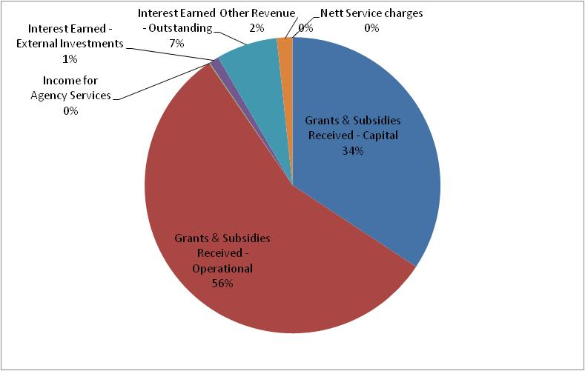

Table 3 Revenue by main revenue source



Total Revenue increased from R805 million in the 2020/21 Draft Budget to R842 million in the 2020/21 Final Budget.

The 5% increase is largely as result of an increase in inclusion of the Disaster Relief Grant and Department of Roads and Transport Grant.

The following table gives a breakdown of the various operating grants and subsidies allocated to the municipality over the medium term:

Table 4 Operating Transfers and Grant Receipts



Tariff-setting is a pivotal and strategic part of the compilation of any budget. When rates, tariffs and other charges were revised, local economic conditions, input costs, Value added tax increase and the affordability of services were taken into account to ensure the financial sustainability of the municipality.

National Treasury continues to encourage municipalities to keep increases in rates, tariffs and other charges as low as possible. Municipalities must justify in their budget documentation all increases in excess of the 6.45 percent. Excessive increases are likely to be counterproductive, resulting in higher levels of non-payment. The municipality decided against using a blanket approach in setting tariffs. The basic charges and consumption charges on conventional meters and that on pre-paid meters were increased in line with the costs associated with the service. The increase on average amounts to an increase of 6.45 percent. Some services where therefore more affected than others.

It must also be appreciated that the consumer price index, as measured by CPI, is not a good measure of the cost increases of goods and services relevant to municipalities.

The basket of goods and services utilised for the calculation of the CPI consist of items such as food, petrol and medical services, whereas the cost drivers of a municipality are informed by items such as the cost of remuneration, bulk purchases of water, petrol, diesel, chemicals, cement etc. The current challenges facing the Municipality is managing the gap between cost drivers and tariffs levied, as any shortfall must be made up by either operational efficiency gains or service level reductions.

## Operating Expenditure Framework

The Municipality’s expenditure framework for the 2020/21 budget and MTREF is informed by the following:

* The asset renewal strategy and the repairs and maintenance plan;
* Balanced budget constraint (operating expenditure should not exceed operating revenue) unless there are existing uncommitted cash-backed reserves to fund any deficit;
* Funding of the budget over the medium-term as informed by Section 18 and 19 of the MFMA;
* The capital programme is aligned to the asset renewal strategy and backlog eradication plan;

The following table is a high level summary of the 2020/21 budget and MTREF (classified per main type of operating expenditure):

Table 5 Summary of operating expenditure by standard classification item



Table 6 Percentage growth in expenditure by main expenditure type



Fig 2: Expenditure by major type

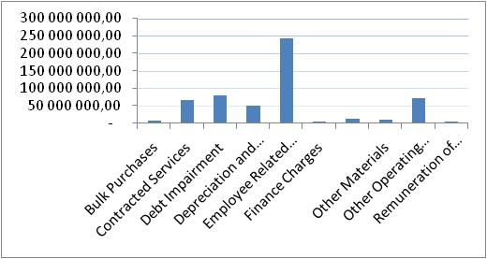

The budgeted allocation for employee related costs for the 2020/21 financial year totals R 242 million, which equals 44 percent of the total operating expenditure. This is 4% above the norm. The high rate is as result of the municipality reducing operating expenditure in order to ensure that the municipality has a funded budget. Employee Related Costs increased by 6.25% as per the Wage Collective Agreement.

The cost associated with the remuneration of Councilors is determined by the Minister of Co-operative Governance and Traditional Affairs in accordance with the Remuneration of Public Office Bearers Act, 1998 (Act 20 of 1998). The most recent proclamation in this regard has been taken into account in compiling the Municipality’s budget.

During the prior year’s Budget Engagement process, Provincial Treasury adviced that the municipality should budget for debt impairment on percentage not collected. The budgeted collection rate is 30% on consumers with conventional meters and 100% on consumers with pre-paid water meters. As per Provincial Treasury’s advice, the municipality should therefore use the remaining 70% as the provision of debt impairment. The municipality decided to only apply the 70% to residential consumers with conventional meters. The total budgeted collection rate is 40% in the current year (2020/21) and 45% for the two outer years (2021/22 and 2022/23). For the 2020/21 financial year this amount equates to R 79 million. While this expenditure is considered to be a non-cash flow item, it informed the total cost associated with rendering the services of the municipality, as well as the municipality’s realistically anticipated revenues.

Provision for depreciation and asset impairment has been informed by the Municipality’s Asset Management Policy. Depreciation is widely considered a proxy for the measurement of the rate asset consumption. Budget appropriations in this regard total R 50 million for the 2020/21 financial year and equates to 9 percent of the total operating expenditure.

Finance charges consist primarily of the repayment of interest on long-term borrowing, frontloading and interest on non-current provisions. Finance charges (R 5.7 million) equates to 1 percent of the operating expenditure excluding annual redemption for 2020/21 financial year.

Bulk Purchases are allocated R9 million for 2020/21 financial year.

Repairs and Maintenance allocation is R 72.6 million (including the employee costs, amounting to R49 million, of departments responsible for repairs and maintenance) for the 2020/21 financial year. The portion reflective as repairs and maintenance is 13 percent of total operational expenditure. Bulk of the cost associated with repairs and maintenance comprises of employee costs, which comprises 67% of the total employee costs.

The municipality decided to use the percentage of total operational expenditure instead of percentage of property, plant and equipment. The percentage of property, plant and equipment would require 48% of the Equitable share to be allocated to Repairs and maintenance, as evident from the table below.



Fig 3: Expenditure by major type – 2020/21

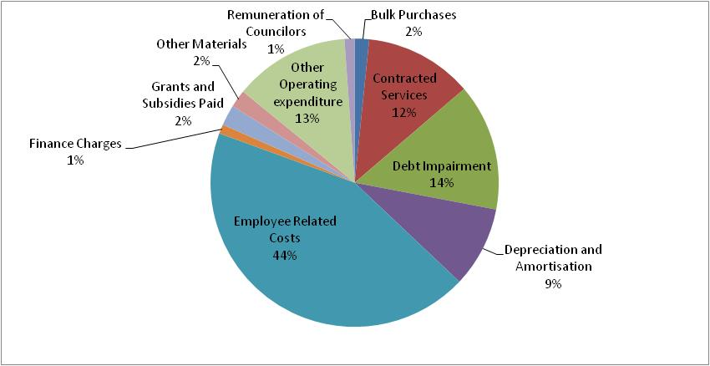

**Free Basic Services: Basic Social Services Package**

The social package assists households that are poor or face other circumstances that limit their ability to pay for services. To receive these free services the households are required to register in terms of the Municipality’s Indigent Policy. The qualifying indigents will be provided with 6kl of water per month

## Capital expenditure

The following table provides a breakdown of budgeted capital expenditure by vote, functional classification and funding:

Table 7 2020/21 Medium-term capital budget per vote



## Annual Budget Tables

The following pages present the main budget tables as required in terms of section 8 of the Municipal Budget and Reporting Regulations. These tables set out the municipality’s 2020/21 budget and MTREF as approved by the Council. Each table is accompanied by explanatory notes on the facing page.

Table 8 MBRR NT A1 - Budget Summary





**Explanatory notes to MBRR Table A1 - Budget Summary**

1. Table A1 is a budget summary and provides a concise overview of the Municipality’s budget from all of the major financial perspectives (operating, capital expenditure, financial position, cash flow, and MFMA funding compliance).
2. The table provides an overview of the amounts approved by Council for operating performance, resources deployed to capital expenditure, financial position, cash and funding compliance, as well as the municipality’s commitment to eliminating basic service delivery backlogs.
3. Financial management reforms emphasises the importance of the municipal budget being funded. This requires the simultaneous assessment of the Financial Performance, Financial Position and Cash Flow Budgets, along with the Capital Budget. The Budget Summary provides the key information in this regard:
   1. The operating surplus/deficit (after Total Expenditure) is positive over the MTREF
   2. Capital expenditure is balanced by capital funding sources, of which
      1. Transfers recognised is reflected on the Financial Performance Budget;
      2. Borrowing is incorporated in the net cash from financing on the Cash Flow Budget
      3. Internally generated funds are financed from a combination of the current  
         operating surplus and accumulated cash-backed surpluses from previous years.

The amount is incorporated in the Net cash from investing on the Cash Flow

Budget. The fact that the municipality’s cash flow remains positive, and is

improving indicates that the necessary cash resources are available to fund the

Capital Budget.

1. The Cash backing/surplus reconciliation shows that in previous financial years the municipality successfully managed to restore its financial viability and consequently its obligations are cash-backed.

**Table 9 MBRR NT A2 - Budgeted Financial Performance (revenue and expenditure by standard classification)**



Explanatory notes to MBRR Table A2 - Budgeted Financial Performance (revenue and expenditure by standard classification)

1. Table A2 is a view of the budgeted financial performance in relation to revenue and expenditure per standard classification. The modified GFS standard classification divides the municipal services into 15 functional areas. Municipal revenue, operating expenditure and capital expenditure are then classified in terms if each of these functional areas which enables the National Treasury to compile ‘whole of government’ reports.
2. Note the Total Revenue on this table includes capital revenues (Transfers recognised – capital) and so does not balance to the operating revenue shown on Table A4.
3. Note that as a general principle the revenues for the Trading Services should exceed their expenditures.
4. Other functions that show a deficit between revenue and expenditure are being financed from rates revenues and other revenue sources reflected under Finance and Asset Management.

Table 10 MBRR NT A3 - Budgeted Financial Performance (revenue and expenditure by municipal vote)



**Explanatory notes to MBRR Table A3 - Budgeted Financial Performance (revenue and expenditure by municipal vote)**

1. Table A3 is a view of the budgeted financial performance in relation to the revenue and expenditure per municipal vote. This table facilitates the view of the budgeted operating performance in relation to the updated organisational structure of the Municipality. This means it is possible to present the operating surplus or deficit of a vote.

Table 11 MBRR NT A4 - Budgeted Financial Performance (revenue and expenditure)



**Explanatory notes to Table A4 - Budgeted Financial Performance (revenue and expenditure)**

1. Budgeted total revenue amount to R842 million in 2020/21.
2. Transfers recognised – operating includes the local government equitable share and other operating grants from national and provincial government.
3. Employee related costs and other expenditure are the main cost drivers within the municipality and alternative operational gains and efficiencies will have to be identified to lessen the impact of wage and bulk tariff increases in future years.

Table 12 MBRR NT A5 - Budgeted Capital Expenditure by vote, standard classification and funding source  


**Explanatory notes to Table A5 - Budgeted Capital Expenditure by vote, standard classification and funding source**

1. Table A5 is a breakdown of the capital programme in relation to capital expenditure by municipal vote (multi-year and single-year appropriations); capital expenditure by standard classification; and the funding sources necessary to fund the capital budget, including information on capital transfers from national and provincial departments.
2. The MFMA provides that a municipality may approve multi-year or single-year capital budget appropriations.
3. Single-year capital expenditure has been appropriated at R 73.7 million for the 2020/21 financial year.
4. Multi-year capital expenditure has been appropriated at R 230 million for the 2020/21 financial year.
5. Unlike multi-year capital appropriations, single-year appropriations relate to expenditure that will be incurred in the specific budget year.
6. The capital programmes are funded from national grants and external loans.

Table 13 MBRR NT A6 - Budgeted Financial Position  


**Explanatory notes to Table A6 - Budgeted Financial Position**

1. Table A6 is consistent with international standards of good financial management practice, and improves understandability for councilors and management of the impact of the budget on the statement of financial position (balance sheet).
2. This format of presenting the statement of financial position is aligned to GRAP1, which is generally aligned to the international version which presents Assets less Liabilities as “accounting” Community Wealth. The order of items within each group illustrates items in order of liquidity; i.e. assets readily converted to cash, or liabilities immediately required to be met from cash, appear first.
3. The municipal equivalent of equity is Community Wealth/Equity. The justification is that ownership and the net assets of the municipality belong to the community.
4. Any movement on the Budgeted Financial Performance or the Capital Budget will inevitably impact on the Budgeted Financial Position. As an example, the collection rate assumption will impact on the cash position of the municipality and subsequently inform the level of cash and cash equivalents at year end. Similarly, the collection rate assumption should inform the budget appropriation for debt impairment which in turn would impact on the provision for bad debt. These budget and planning assumptions form a critical link in determining the applicability and relevance of the budget as well as the determination of ratios and financial indicators. In addition the funding compliance assessment is informed directly by forecasting the statement of financial position.

Table 14 MBRR NT A7 - Budgeted Cash Flow Statement

**Explanatory notes to Table A7 - Budgeted Cash Flow Statement**

1. The budgeted cash flow statement is the first measurement in determining if the budget is funded.
2. It shows the expected level of cash in-flow versus cash out-flow that is likely to result from the implementation of the budget.

**Part 2 – Supporting Documentation**

## Overview of the annual budget process

Section 53 of the MFMA requires the Mayor of the municipality to provide general political guidance in the budget process and the setting of priorities that must guide the preparation of the budget. In addition Chapter 2 of the Municipal Budget and Reporting Regulations states that the Mayor of the municipality must establish a Budget Steering Committee to provide technical assistance to the Mayor in discharging the responsibilities set out in section 53 of the Act.

The Budget Steering Committee consists of the Municipal Manager and senior officials of the municipality meeting under the chairpersonship of the Executive Mayor and/or MMC for Finance.

The primary aim of the Budget Steering Committee is to ensure:

* that the process followed to compile the budget complies with legislation and good budget practices;
* that there is proper alignment between the policy and service delivery priorities set out in the Municipality’s IDP and the budget, taking into account the need to protect the financial sustainability of municipality;
* that the municipality’s revenue and tariff setting strategies ensure that the cash resources needed to deliver services are available; and
* that the various spending priorities of the different municipal departments are properly evaluated and prioritised in the allocation of resources.

## Budget Process Overview

In terms of section 21 of the MFMA the Mayor is required to table in Council ten months before the start of the new financial year, a time schedule that sets out the process to revise the IDP and prepare the budget.

The Mayor tabled in Council the required IDP and budget time schedule in August 2019. In accordance with the original budget time schedule the Draft IDP and Draft budget for 2020/21 financial year was adopted by Council on 26 March 2020. In accordance with the original budget time schedule the Final IDP and annual budget for 2020/21 is scheduled to be adopted by Council on 28 May 2020.

### Financial Modeling and Key Planning Drivers

As part of the compilation of the 2020/21 MTREF, financial modelling to ensure affordability and long-term financial sustainability, was undertaken. The following key factors and planning strategies have informed the compilation of the 2020/21 MTREF:

* Municipality growth.
* Policy priorities and strategic objectives.
* Asset maintenance.
* Economic climate and trends (i.e inflation, tariff increases, household debt).
* The approved 2018/19 adjustments budget and performance against the SDBIP.
* Cash Flow Management Strategy.
* Debtor payment levels.
* Loan and investment possibilities.
* The need for tariff increases versus the ability of the community to pay for services.
* Improved and sustainable service delivery.

In addition to the above, the strategic guidance given in National Treasury’s MFMA Circular 66has been taken into consideration in the planning and prioritisation process.

### Community Consultation

The draft 2020/21 MTREF will be tabled before Council for community consultation. Thereafter it will be published on the municipality’s website, and hard copies made available at, municipal notice boards and various municipal offices.

All documents in the appropriate format (electronic and printed) will be provided to National Treasury, and other national and provincial departments in accordance with section 23 of the MFMA, to provide an opportunity for them to make inputs.

Submissions received during the community consultation process and additional information regarding revenue and expenditure and individual capital projects will be addressed, and where relevant considered as part of the finalisation of the 2020/21 MTREF

## Overview of alignment of annual budget with IDP

The Constitution mandates local government with the responsibility to exercise local developmental and cooperative governance. The eradication of imbalances in South African society can only be realized through a credible integrated developmental planning process.

Municipalities in South Africa need to utilise integrated development planning as a method to plan future development in their areas and so find the best solutions to achieve sound long-term development goals. A municipal IDP provides a five year strategic programme of action aimed at setting short, medium and long term strategic and budget priorities to create a development platform, which correlates with the term of office of the political incumbents. The plan aligns the resources and the capacity of a municipality to its overall development aims and guides the municipal budget. An IDP is therefore a key instrument which municipalities use to provide vision, leadership and direction to all those that have a role to play in the development of a municipal area. The IDP enables municipalities to make the best use of scarce resources and speed up service delivery.

Integrated developmental planning in the South African context is amongst others, an approach to planning aimed at involving the municipality and the community to jointly find the best solutions towards sustainable development. Furthermore, integrated development planning provides a strategic environment for managing and guiding all planning, development and decision making in the municipality.

It is important that the IDP developed by municipalities correlate with National and Provincial intent. It must aim to co-ordinate the work of local and other spheres of government in a coherent plan to improve the quality of life for all the people living in that area. Applied to the Municipality, issues of national and provincial importance should be reflected in the IDP of the municipality. A clear understanding of such intent is therefore imperative to ensure that the Municipality strategically complies with the key national and provincial priorities.

The aim of this revision cycle was to develop and coordinate a coherent plan to improve the quality of life for all the people living in the area, also reflecting issues of national and provincial importance. One of the key objectives is therefore to ensure that there exists alignment between national and provincial priorities, policies and strategies and the Municipality’s response to these requirements.

In order to ensure integrated and focused service delivery between all spheres of government it was important for the Municipality to align its budget priorities with that of national and provincial government. All spheres of government place a high priority on infrastructure development, economic development and job creation, efficient service delivery, poverty alleviation and building sound institutional arrangements.

The identification of strategic focus areas which informed the preparation of the IDP and Budget is based on the five key performance areas contained in the 5 Year Local Government Strategic Agenda which are:

* Spatial rationale and analysis.
* Institutional development and transformation.
* Local economic development.
* Infrastructure and service delivery.
* Good governance.
* Financial viability.

## Measurable performance objectives and indicators

Performance Management is a system intended to manage and monitor service delivery progress against the identified strategic objectives and priorities. In accordance with legislative requirements and good business practices as informed by the National Framework for Managing Programme Performance Information, the Municipality has developed and implemented a performance management system of which system is constantly refined as the integrated planning process unfolds. The Municipality target, monitors, assesses and reviews organisational performance which in turn is directly linked to individual employee’s performance.

At any given time within government, information from multiple years is being considered; plans and budgets for next year; implementation for the current year; and reporting on last year's performance. Although performance information is reported publicly during the last stage, the performance information process begins when policies are being developed, and continues through each of the planning, budgeting, implementation and reporting stages. The planning, budgeting and reporting cycle can be graphically illustrated as follows:

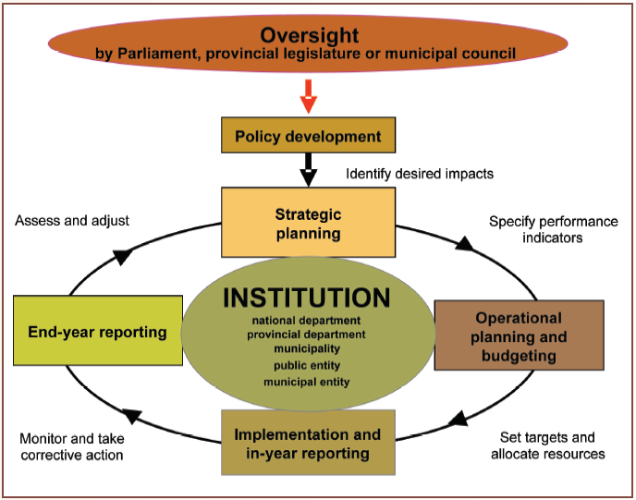

The performance of the Municipality relates directly to the extent to which it has achieved success in realising its goals and objectives, complied with legislative requirements and meeting stakeholder expectations.

The performance information concepts used by the Municipality in its integrated performance management system are aligned to the ***Framework of Managing Programme Performance Information*** issued by the National Treasury:

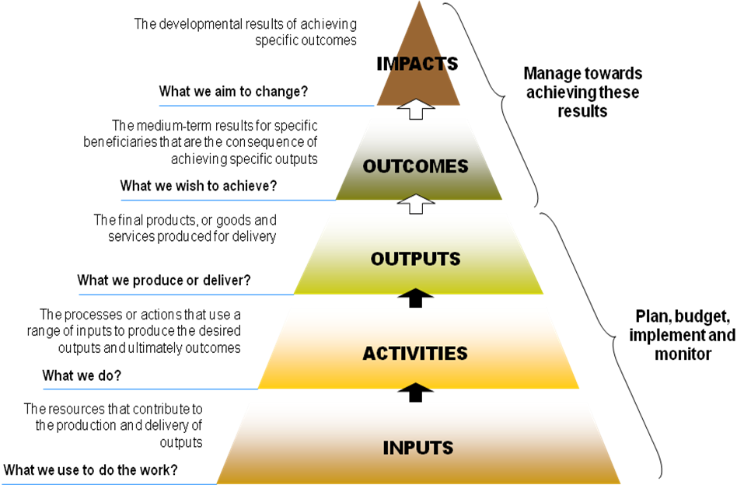

The following table sets out the municipality’s main performance objectives and benchmarks for the 2020/21 MTREF.

Table 15 MBRR NT SA8 – Performance indicators and benchmarks  


## Performance indicators and benchmarks

#### Borrowing Management

Capital expenditure in local government can be funded by capital grants, own-source revenue and long term borrowing. The ability of a municipality to raise long term borrowing is largely dependent on its creditworthiness and financial position. As with all other municipalities, Joe Gqabi District Municipality’s borrowing strategy is primarily informed by the affordability of debt repayments.

The structure of the Municipality’s debt portfolio is dominated by annuity loans. The following financial performance indicators have formed part of the compilation of the 2020/21 MTREF:

* *Capital charges to operating expenditure* is a measure of the cost of borrowing in relation to the operating expenditure. It can be seen that the cost of borrowing has increased from 1.2 percent per the 2019/20 Adjustments Budget to 1.3 percent in 2020/21. This subsequent year increase can be attributed to the estimated front loading loan budgeted for. While borrowing is considered a prudent financial instrument in financing capital infrastructure development, this indicator will have to be carefully monitored going forward as the Municipality will eventually reach its prudential borrowing limits.
* *Borrowing funding of own capital expenditure* measures the degree to which own capital expenditure (excluding grants and contributions) has been funded by way of borrowing.

The Municipality’s debt profile provides some interesting insights on the Municipality’s future borrowing capacity. Firstly, the use of amortising loans leads to high debt service costs at the beginning of the loan, which declines steadily towards the end of the loan’s term.

#### Safety of Capital

* *The gearing ratio* is a measure of the total long term borrowings over funds and reserves. The ratio has been consistent at 0.04 percent.

#### Liquidity

* *Current ratio* is a measure of the current assets divided by the current liabilities and as a benchmark the Municipality has set a limit of 1, hence at no point in time should this ratio be less than 1. For the 2020/21 MTREF the current ratio is 2:1. The estimated levels are better than industry norms.
* *The liquidity ratio* is a measure of the ability of the municipality to utilize cash and cash equivalents to extinguish or retire its current liabilities immediately. Ideally the municipality should have the equivalent cash and cash equivalents on hand to meet at least the current liabilities, which should translate into a liquidity ratio of 1. Anything below 1 indicates a shortage in cash to meet creditor obligations. A negative liquidity ratio needs to be considered a pertinent risk for the municipality as any under collection of revenue will translate into serious financial challenges for the Municipality. As part of the longer term financial planning objectives this ratio will always have to be set at a minimum of 1 which will be exceeded in the MTREF.

#### Other Indicators

* Employee costs as a percentage of operating revenue increased from 34.9 percent during the 2019/20 financial year to 39.5 percent in the 2020/21 financial year and increases steadily over the MTREF.

### Free Basic Services: basic social services package for indigent households

The social package assists residents that have difficulty paying for services and are registered as indigent households in terms of the Indigent Policy of the Municipality. Only registered indigents qualify for the free basic services.

A summary of the free basic services package is set out below:

* All registered indigents, including consumers in the rural areas, will receive 6 kl of water per month fully subsidised.
* All registered indigents, including consumers in the rural areas, will only be charged a flat rate for Water and Sanitation consumption and not a step tariff.

The cost of the social package of the registered indigent households is largely financed by national government through the local government equitable share received in terms of the annual Division of Revenue Act.

## Overview of budget related-policies

The Municipality’s budgeting process is guided and governed by relevant legislation, frameworks, strategies and related policies.

### Review of credit control and debt collection procedures/policies

The Credit Control and Debt Collection Policy has been approved by Council in May 2012. While the adopted policy is credible, sustainable, manageable and informed by affordability and value for money there has been a need to review certain components to achieve a higher collection rate. Some of the possible revisions will include the increasing of the credit periods for the down payment of debt. In addition emphasis will be placed on latest legislation changes and court rulings to ensure that credit control and debt collection efforts are not fruitlessly wasted on these debtors.

The 2020/21 MTREF has been prepared on the basis of achieving an average debtors’ collection rate of 40 percent on current billings (30 percent on conventional consumers and 100 percent on pre-paid consumers). In addition, the collection of debt in excess of 90 days has been prioritised as a pertinent strategy in increasing the Municipality’s cash levels.

### Asset Management, Infrastructure Investment and Funding Policy

A proxy for asset consumption can be considered the level of depreciation each asset incurs on an annual basis. Preserving the investment in existing infrastructure needs to be considered a significant strategy in ensuring the future sustainability of infrastructure and the Municipality’s revenue base.

Within the framework, the need for asset renewal was considered a priority and hence the capital programme was determined based on renewal of current assets versus new asset construction.

Further, continued improvements in technology generally allows many assets to be renewed at a lesser ‘real’ cost than the original construction cost. Therefore, it is considered prudent to allow for a slightly lesser continual level of annual renewal than the average annual depreciation. The Asset Management, Infrastructure and Funding Policy is therefore considered a strategic guide in ensuring a sustainable approach to asset renewal, repairs and maintenance and is utilised as a guide to the selection and prioritisation of individual capital projects. In addition the policy prescribes the accounting and administrative policies and procedures relating to property, plant and equipment (fixed assets).

### Supply Chain Management Policy

No changes were made to the existing Supply Chain Management Policy.

### Budget and Virement Policy

The Budget and Virement Policy aims to empower senior managers with an efficient financial and budgetary amendment and control system to ensure optimum service delivery within the legislative framework of the MFMA and the Municipality’s system of delegations. With the implementation of mSCOA, virements from repairs and maintenance to operating expenditure will not be possible. This is to improve the municipality’s ration to Property, plant and equipment or total operating expenditure, which has been below the recommended threshold in recent years.

### Cash Management and Investment Policy

No changes were made to the Municipality’s Cash Management and Investment Policy. The aim of the policy is to ensure that the Municipality’s surplus cash and investments are adequately managed, especially the funds set aside for the cash backing of certain reserves.

### Tariff Policy

The Municipality’s tariff policy provide a broad framework within which the Council can determine fair, transparent and affordable charges that also promote sustainable service delivery. The policy have been approved on various dates and a consolidated tariff policy is envisaged to be compiled for ease of administration and implementation over the next two years.

## Overview of budget assumptions

### External factors

Owing to the economic slowdown, financial resources are limited. This has resulted in declining cash inflows. This together with the coronavirus pandemic and the uncertain costs which it might cause has necessitated restrained expenditure to ensure that cash outflows remain within the affordability parameters of the Municipality’s finances.

### General inflation outlook and its impact on the municipal activities

There are five key factors that have been taken into consideration in the compilation of the 2020/21 MTREF:

* National Government macro economic targets;
* The general inflationary outlook and the impact on Municipality’s residents and businesses;
* The impact of municipal cost drivers;
* The increase in prices for bulk water; and
* The increase in the cost of remuneration. The wage agreement negotiated by SALGBC.

### Collection rate for revenue services

The base assumption is that tariff and rating increases will increase at a rate slightly higher that CPI over the long term. It is also assumed that current economic conditions, and relatively controlled inflationary conditions, will continue for the forecasted term. The Collection rate has been budgeted at 37% of the Service Charges. The debt collection policy will be reviewed in order to (after conducting public participation) to allow the municipality to deduct a percentage of pre-paid water sales as part payment towards the relevant consumers’ arrears.

### Salary increases

The salary increase amounted to 6.25%, as per the collective agreement regarding salaries/wages for the 2020/21 financial year.

### Impact of national, provincial and local policies

Integration of service delivery between national, provincial and local government is critical to ensure focussed service delivery and in this regard various measures were implemented to align IDPs, provincial and national strategies around priority spatial interventions. In this regard, the following national priorities form the basis of all integration initiatives:

* Creating jobs;
* Infrastructure Development
* Enhancing education and skill development;
* Improving Health services;
* Rural development and agriculture; and
* Strengthening financial management in public sector

To achieve these priorities integration mechanisms are in place to ensure integrated planning and execution of various development programs. The focus will be to strengthen the link between policy priorities and expenditure thereby ensuring the achievement of the national, provincial and local objectives.

### Ability of the municipality to spend and deliver on the programmes

It is estimated that a spending rate of 100 percent is achieved on operating expenditure and on the capital programme for the 2020/21 MTREF of which performance has been factored into the cash flow budget. The municipality has limited funding. Programmes and Service Delivery have been prioritised.

## Overview of budget funding

### Medium-term outlook: operating revenue

The following table is a breakdown of the operating revenue over the medium-term:

Table 16 Breakdown of the operating revenue over the medium-term



### Medium-term outlook: capital revenue

The following table is a breakdown of the funding composition of the 2020/21 medium-term capital programme:

Table 17 Sources of capital revenue over the MTREF



The capital programmes are funded from National Grants and transfers, as well as internally generated funds and Borrowings. Internally generated funds comprise of Water and Sanitation Service Charges.

### Cash Flow Management

Cash flow management and forecasting is a critical step in determining if the budget is funded over the medium-term. The table below is consistent with international standards of good financial management practice and also improves understandability for councillors and management. Some specific features include:

* Clear separation of receipts and payments within each cash flow category;
* Clear separation of capital and operating receipts from government, which also enables cash from ‘Ratepayers and other’ to be provide for as cash inflow based on actual performance. In other words the *actual collection rate* of billed revenue., and
* Separation of borrowing and loan repayments (no set-off), to assist with MFMA compliance assessment regarding the use of long term borrowing (debt).

Table 18 MBRR NT A7 - Budget cash flow statement



### Cash Backed Reserves/Accumulated Surplus Reconciliation

This following table meets the requirements of MFMA Circular 72 which deals with the funding of a municipal budget in accordance with sections 18 and 19 of the MFMA. The table seeks to answer three key questions regarding the use and availability of cash:

* What are the predicted cash and investments that are available at the end of the budget year?
* How are those funds used?
* What is the net funds available or funding shortfall?

A surplus would indicate the cash-backed accumulated surplus that was/is available. A shortfall (applications > cash and investments) is indicative of non-compliance with section 18 of the MFMA requirement that the municipality’s budget must be ‘funded’.

Non-compliance with section 18 is assumed because a shortfall would indirectly indicate that the annual budget is not appropriately funded (budgeted spending is greater than funds available or to be collected). It is also important to analyse trends to understand the consequences, e.g. the budget year might indicate a small surplus situation, which in itself is an appropriate outcome, but if in prior years there were much larger surpluses then this negative trend may be a concern that requires closer examination.

Table 19 MBRR NT A8 - Cash backed reserves/accumulated surplus reconciliation



### Funding compliance measurement

National Treasury requires that the municipality assess its financial sustainability against fourteen different measures that look at various aspects of the financial health of the municipality. These measures are contained in the following table. All the information comes directly from the annual budgeted statements of financial performance, financial position and cash flows. The funding compliance measurement table essentially measures the degree to which the proposed budget complies with the funding requirements of the MFMA. Each of the measures is discussed below.

#### Cash/cash equivalent position

The Municipality’s forecast cash position was discussed as part of the budgeted cash flow statement. A ‘positive’ cash position, for each year of the MTREF would generally be a minimum requirement, subject to the planned application of these funds such as cash-backing of reserves and working capital requirements.

If the municipality’s forecast cash position is negative, for any year of the medium term budget, the budget is very unlikely to meet MFMA requirements or be sustainable and could indicate a risk of non-compliance with section 45 of the MFMA which deals with the repayment of short term debt at the end of the financial year.

#### Cash plus investments less application of funds

The purpose of this measure is to understand how the municipality has applied the available cash and investments as identified in the budgeted cash flow statement. The reconciliation is intended to be a relatively simple methodology for understanding the budgeted amount of cash and investments available with any planned or required applications to be made. This has been extensively discussed above.

#### Monthly average payments covered by cash or cash equivalents

The purpose of this measure is to understand the level of financial risk should the municipality be under stress from a collection and cash in-flow perspective. Regardless of the annual cash position an evaluation should be made of the ability of the Municipality to meet monthly payments as and when they fall due. It is especially important to consider the position should the municipality be faced with an unexpected disaster that threatens revenue collection such as rate boycotts. As indicated above the Municipality aims to achieve at least one month’s cash coverage in the medium term, and then gradually move towards two months coverage. This measure will have to be carefully monitored going forward.

#### Surplus/deficit excluding depreciation offsets

The main purpose of this measure is to understand if the revenue levels are sufficient to conclude that the community is making a sufficient contribution for the municipal resources consumed each year. An ‘adjusted’ surplus/deficit is achieved by offsetting the amount of depreciation related to externally funded assets. Municipalities need to assess the result of this calculation taking into consideration its own circumstances and levels of backlogs. If the outcome is a deficit, it may indicate that rates and service charges are insufficient to ensure that the community is making a sufficient contribution toward the economic benefits they are consuming over the medium term.

It needs to be noted that a surplus does not necessarily mean that the budget is funded from a cash flow perspective and the first two measures in the table are therefore critical.

Table 20 MBRR NT SA10 - Funding compliance measurement





#### Debt impairment expense as a percentage of billable revenue

This factor measures whether the provision for debt impairment is being adequately funded and is based on the underlying assumption that the provision for debt impairment (doubtful and bad debts) has to be increased to offset under-collection of billed revenues. Considering the debt incentive scheme and the municipality’s revenue management strategy’s objective to collect outstanding debtors of 90 days, the provision is well within the accepted leading practice.

#### Capital payments percentage of capital expenditure

The purpose of this measure is to determine whether the timing of payments has been taken into consideration when forecasting the cash position. The municipality aims to keep this as low as possible through strict compliance with the legislative requirement that creditors be paid within 30 days.

#### Transfers/grants revenue as a percentage of Government transfers/grants available

The purpose of this measurement is mainly to ensure that all available transfers from national and provincial government have been budgeted for. A percentage less than 100 percent could indicate that not all grants as contained in the Division of Revenue Act (DoRA) have been budgeted for. The Municipality has budgeted for all transfers.

#### Repairs and maintenance expenditure level

This measure must be considered important within the context of the funding measures criteria because a trend that indicates insufficient funds are being committed to asset repair could also indicate that the overall budget is not credible and/or sustainable in the medium to long term because the revenue budget is not being protected.

#### Asset renewal/rehabilitation expenditure level

This measure has a similar objective to aforementioned objective relating to repairs and maintenance. A requirement of the detailed capital budget (since MFMA Circular 28 which was issued in December 2005) is to categorise each capital project as a new asset or a existing asset renewal/upgrading project. The objective is to summarise and understand the proportion of budgets being provided for new assets and also asset sustainability. A declining or low level of renewal funding may indicate that a budget is not credible and/or sustainable and future revenue is not being protected, similar to the justification for ‘repairs and maintenance’ budgets.

## Expenditure on grants and reconciliations of unspent funds

Table 21 MBRR SA19 - Expenditure on transfers and grant programmes



Contracts having future budgetary implications

In terms of the Municipality’s Supply Chain Management Policy, no contracts are awarded beyond the medium-term revenue and expenditure framework (three years). In ensuring adherence to this contractual time frame limitation, all reports submitted to either the Bid Evaluation and Adjudication Committees must obtain formal financial comments from the Financial Management Division of the Treasury Department.

## Capital expenditure details

The following tables present details of the Municipality’s capital expenditure programme.

Table 22 2020/21 Capital expenditure by asset class











## Legislation compliance status

Compliance with the MFMA implementation requirements have been substantially adhered to through the following activities:

* + - 1. In year reporting

Reporting to National Treasury in electronic format was fully complied with on a monthly basis. Section 71 reporting to the Executive Mayor (within 10 working days) has progressively improved and includes monthly published financial performance on the Municipality’s website.

* + - 1. Internship programme

The Municipality is participating in the Municipal Financial Management Internship programme and is intending to employ interns to undergo training in various divisions of the Budget and Treasury Office.

* + - 1. Budget and Treasury Office

The Budget and Treasury Office has been established in accordance with the MFMA.

* + - 1. Audit Committee

An Audit Committee has been established and is fully functional.

* + - 1. Service Delivery and Implementation Plan

The detail SDBIP document has been reviewed and will be finalised after approval of the 2020/21 MTREF on 28 May 2020 directly aligned and informed by the 2020/21 MTREF.

* + - 1. Annual Report

Annual report has been compiled in terms of the MFMA and National Treasury requirements.

1. MFMA Training

The MFMA training module in electronic format is presented at the Municipality’s internal centre and training is ongoing.

.

## Municipal manager’s quality certificate

I ________________________________________, Municipal Manager of Joe Gqabi District Municipality hereby certify that the annual budget and supporting documentation have been prepared in accordance with the Municipal Finance Management Act 56 of 2003 and the regulations made under the Act, and that the annual budget and supporting documents are consistent with the Integrated Development Plan of the municipality.

Signature

________________________________________

ZA Williams

Municipal Manager

Joe Gqabi District Municipality (DC14)

Date: ____________________